Product object
Id, pname, price etc
By default json server id unique consider. But if we use pid(it can duplicate).
http://localhost:3000/products all product details
Get : Get resources in json format like products
http://localhost:3000/products/100 search particular product details
Get with path param : search resource base upon unique property
Id
Post : store the product details

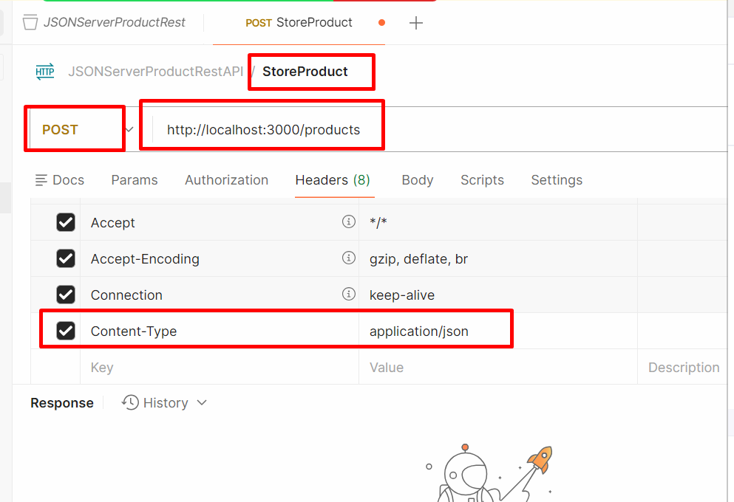

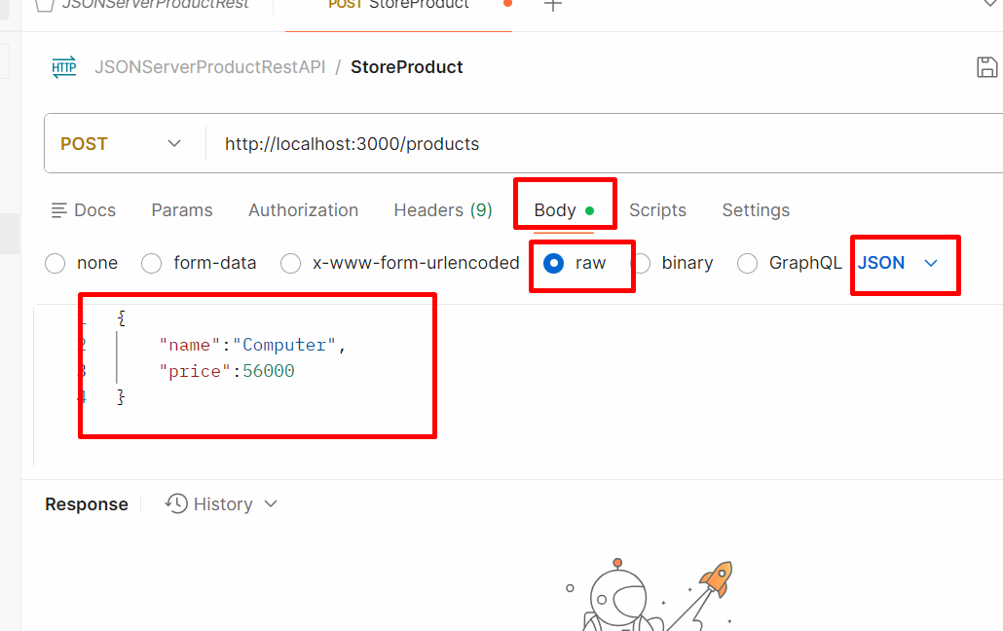

Put : update the product information using id property
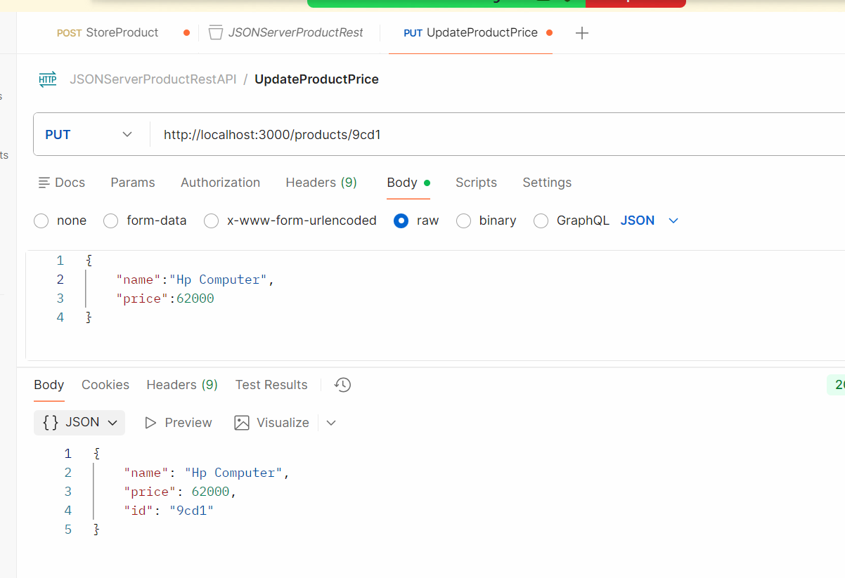

Delete : delete method is use to delete the product using id property

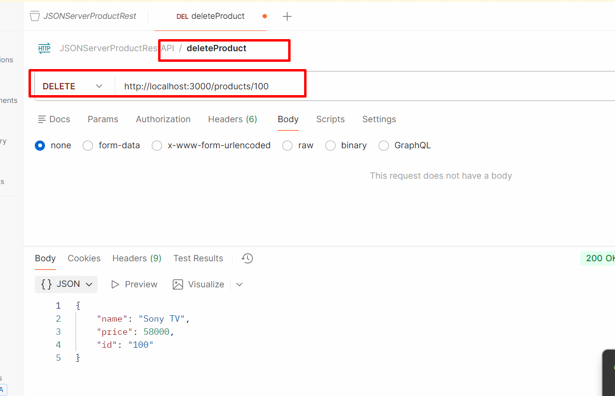

To test these http method we need rest api plugin ie postman or we can test using curl command also.

